

Wheelchair Use
Rules and Guidelines

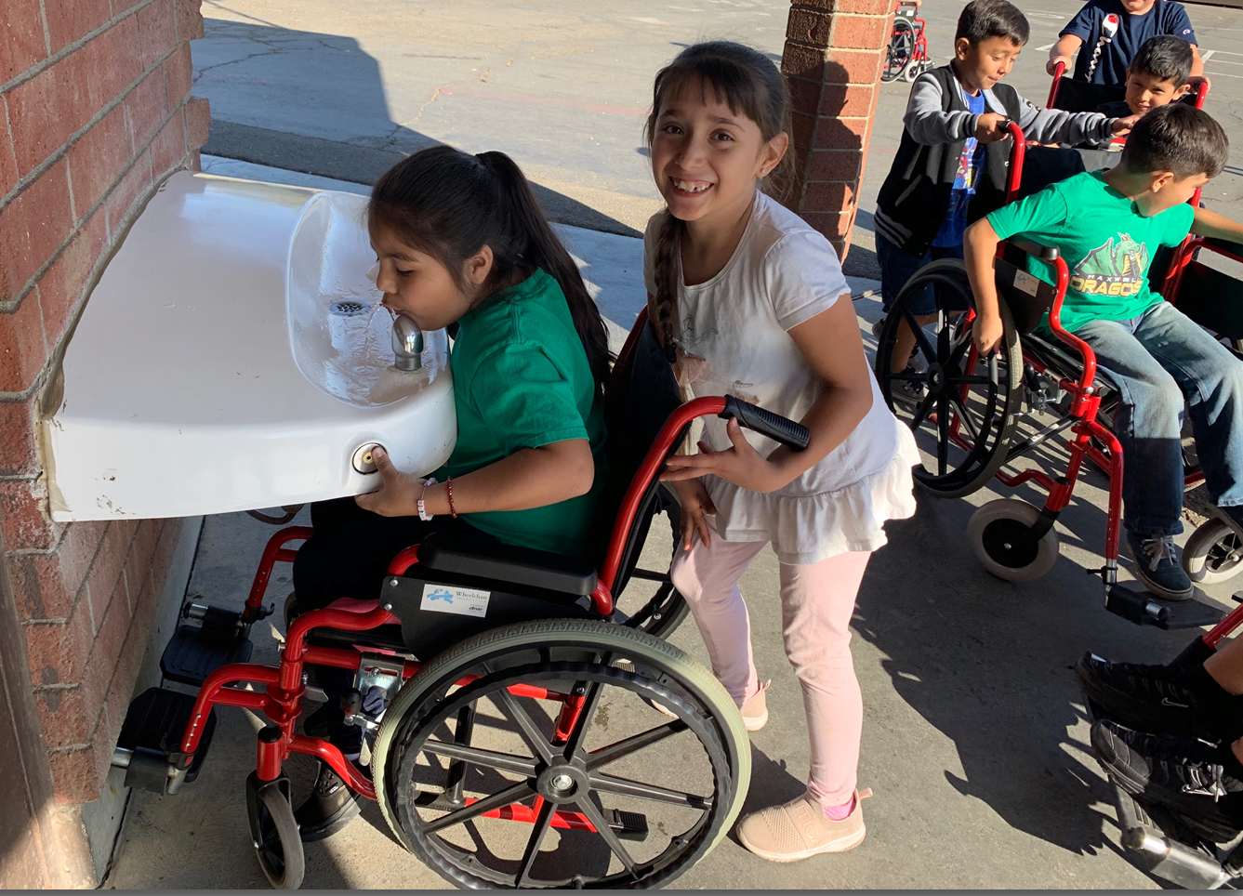

The wheelchairs that you will be using are the same wheelchairs that the Foundation delivers around the world. They are quite sturdy and are expected to last for many years with normal usage. However, if they are mistreated or abused they can be damaged. We did have one school where two wheelchairs were damaged beyond repair and had to be replaced at a cost of $200 each.
Please adhere to the following rules in order to ensure that the wheelchairs are well maintained and can be used by the school that is scheduled to get them next.
- To fold the wheelchair pull up on the strap that is on the seat (do not force).
- To open the wheelchair, press down with your palms on the front of the bars on either side of the seat (do not force and be careful not to get your fingers caught!)
- Treat the wheelchair like you would treat a new bike.
- No more than one person at a time should be sitting in the wheelchair
- Wheelchair use by students should be supervised as much as possible.
- Only mature, responsible students should be allowed to use the wheelchairs without direct supervision.
- The wheelchairs are not to be taken home by students.
- The wheelchairs can be used for off-campus fundraising if there is a responsible adult or high school student responsible for the wheelchair(s).
- If you are having any problems with a wheelchair not working please report it to communityoutreach@wheelchairfoundation.org or 925-655-7905

