Week Of Wheelchairs
Ideas To Make An Impact

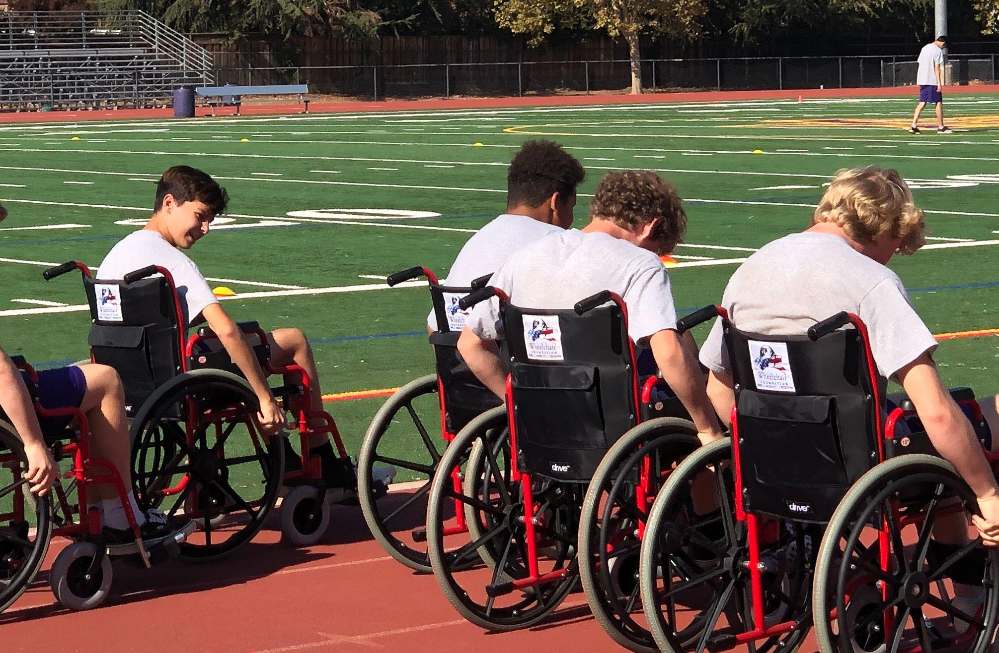

Introduction
There are many ways for your school to use the 10 wheelchairs to impact your students. The goal is for students to experience some of the challenges faced by those with mobility disabilities. However, wheelchairs are not meant to be seen as a hindrance or burden. On the contrary! A wheelchair is the gift of mobility for people who, without a wheelchair, are forced to crawl, be carried or isolated in their homes. With a wheelchair people can go to school, work, and participate in their community. A wheelchair provides mobility, freedom, dignity, and hope! In the following pages are some ideas on how to use the 10 wheelchairs available to your school for the week. Feel free to use these ideas as outlined below or come up with your own!
For rules and guidelines on wheelchair use click HERE

Wheelchair Use In The Classroom

Wheelchairs can be distributed throughout the school by grade level.
For example:

Monday K-1
Tuesday 2nd
Wednesday 3rd
Thursday 4th
Friday 5th

Teachers can allow students to use wheelchairs throughout the school day (half day, 10 min or whatever time increment you choose) so that students participating experience the daily challenges of using a wheelchair for mobility. This is a voluntary activity for students. Additionally, teachers and administrators can make a huge impact by using a wheelchair for a full day or half day to do their job.

Time for group reflection is a very powerful learning tool to raise empathy and sensitivity after the experience is complete.

Wheelchair Activities for P.E. Use

This is a popular way schools have used wheelchairs. Using the wheelchairs during PE class allows all students to experience some of the challenges faced by wheelchair users every day.

Wheelchair Course
- 4 to 10 wheelchairs – (depending on number of students and space)
- Equipment: Cones, starting line, stopping line, wheelchairs, jump ropes, and bean bags.

Lower Grades
Set up cones to mark starting and ending points a few yards from each other. Each pair of cones represents one line.
Have students form equal lines behind each starting point cone.
Have one wheelchair available per line.

***Safety - Make sure breaks are “on” when a student is getting in a wheelchair and then again before getting out of the wheelchair. ***

The first student in line sits in the wheelchair. Once the wheelchair user is ready, they give the “thumbs-up” sign and the second student in line will then roll/push the wheelchair user to the opposite cone, being careful of speed, safety, and comfort of the friend in the wheelchair. Turn the wheelchair around and head back to the start line. Switch positions and repeat.

Continue until all students have had a turn, and then repeat the process with the first student maneuvering the wheelchair by themselves, having their partner assist them only when needed. Students can ask for assistance. Continue until all have had a chance to try to control the wheelchair on their own.

Upper Grades

Have an equal number of markers on either side of course: length of course to be
determined with cones and distance depends on the age of students and space available.
Have an equal number of students stand behind each marker. See below

X X X l l X X X

The first student in line sits in the wheelchair and the next student in line rolls/pushes their partner to the opposite side of the playing area where another student is waiting. The student gets out of the chair holding for the next person in line and then goes to the back of the line.

Add to Course: Place a few cones along the path to zigzag through (enjoyable, but does not present excessive hardship) Also try having wheelchair users roll over jump ropes or pick up items like beanbags.

Continue until everyone has a turn.

If there is extra time, try the course backwards!

Talking Points:

Lower Grades - How does it feel to use a wheelchair for mobility? How does it feel to have someone else in charge of where you go and how fast or slow you go? How would you feel if you had to use a wheelchair all day with someone pushing you and making decisions for you? What would you like or dislike about using a wheelchair? How could you show kindness to someone in a wheelchair, or to someone who uses crutches or a brace? Should you touch someone’s wheelchair, brace, or crutches without asking? (Focus here on the respect for all regardless if they need help to move or not)

Upper Grades - Ask additional questions to the ones above like: How does it feel not to be able to get to where you want to go easily or to struggle to move quickly? What are some ways you can assist someone who has mobility issues. (Hint: always ask first if you can help.) Also see Wheelchair Etiquette.

Additional PE Activities

Set up opportunities for students to explore using wheelchairs in different play scenarios.

Wheelchair Basketball

Wheelchair basketball can be played as a part of PE class, but many schools have also used a game of basketball to add excitement to assemblies or lunchtime activities for awareness. An idea for assemblies or lunchtime games would be to have students play staff.

Have one or two wheelchairs per half court and up to 6 students per half court. Place a hula-hoop over the basket so that students in wheelchairs have a more accessible “basket” if they wish.

Lower Grade students can take several turns trying to hold a basketball or foam ball in their lap while maneuvering on the court and attempting to make a shot. Those not in wheelchairs can be passed to, and can assist by retrieving balls after shots are made. Each student can participate in a wheelchair until the whistle is blown and the next group of students take a turn. Repeat until all have had a turn.

Upper Grades - If you would like to make this activity more involved for older students then you could have a small game of three-on-three wheelchair basketball on each half court with support offered from other students to keep the ball inbounds. Players can move with the ball on lap for three pushes on wheels before passing to a teammate. Modify the game as you see fit so that it is fun but challenging. Perhaps have alternate stations for this activity so that you can manage the small game with other students engaged in station work.

Talking Points
- Ask students to share what they found enjoyable or challenging.
- Ask them if they thought that the rules of basketball could be changed to make a person playing in a wheelchair with others more fair.
- What might some of your ideas be to change the game to include those with a disability like not being able to walk. (Not using your legs to jump while shooting a basket really changes the trajectory of the ball.)
- Ask students how they thought sitting and shooting a basket felt and perhaps talk about what power is lost when you are unable to use only your upper body.

Four-Square

Another fun option is to play four-square. Have one player in a wheelchair per court, with the other 3 students on their feet. For lower grade students a balloon can be used instead of the standard bouncy ball. Either modify the game to accommodate for the students using wheelchairs, or ask students to brainstorm how the rules can be changed to include and challenge all the players regardless of their abilities.

Raising Empathy Without The Use Of Wheelchairs

Challenge students to sit on the ground and move from point A to point B without the use of their legs. Emphasize that their legs are not to be used to help with forward motion. Talk about all the different ways they tried to make it across the space. Ask the students how it made them feel to move in that way. Chances are you did so in the grass or in the MPR, how would it have felt to do so on the black top or on a dirt or gravel road. Remind students that these are just some of the challenges that many people without wheelchairs are faced with each and every day, especially in developing countries.

Wheelchair Activities Ideas Outside of PE

Several Leadership Students can sit in front of the school in a wheelchair(s) each day during drop-off and pick-up to raise awareness of that day's activities. Posters to alert the student body and parents of the upcoming events are helpful as well. Alternatively, several students and/or teachers can do traffic duty in a wheelchair.

Wheelchair For A Day

Responsible students can sign up to use a wheelchair around campus for a full school day. Or, teachers can sign-up to teach from a wheelchair for a day. Either way, this activity gives great visibility to your program! Additionally, participants can write about their experiences and thoughts about how this activity changed their perspective on those with disabilities and publish these entries on social media, newsletters, in assemblies, class, etc.

Wheelchair Obstacle course or challenges during lunchtime or recess time

The obstacle course is up to your imagination. It can be something as simple as using cones to weave around, jump ropes to go over and chalk lines to follow. If you have an uphill to your black top, use that as well.

Challenges can also include an obstacle course designed to educate students about some of the obstacles faced every day by wheelchair users. For example, closed doorways (where they have to open a heavy door), curb cuts, and tight spaces between desks, slight inclines and crossing grass in the course design.

Here are some other challenges to consider: Have stations 50 feet apart where the wheelchair user is given the following and told to take it to the next station:
- An open umbrella
- A cup of water
- A few loose papers and a pen
- A basketball
- A heavy backpack

