Movie And Video Resource List
Movies can be a meaningful way to build empathy, understanding, and awareness while encouraging conversations about inclusion, kindness, perseverance, and seeing the world from another person’s perspective.
The movies listed here are suggestions and may not be appropriate for every age or audience, so please preview each selection before sharing it with students.
Movies can be used as part of a classroom lesson, schoolwide activity, or Family Fun Night fundraiser. Schools may also provide discussion questions or talking points before or after the movie to help students and families connect the experience back to the values of From The Heart.



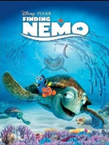
Finding Nemo (2003) G
Disability: Short Term Memory Loss and Physical Challenges
Summary: After his son is captured in the Great Barrier Reef and taken to Sydney, a timid clownfish sets out on a journey to bring him home. Dory has short term memory loss, and Nemo has a "lucky fin," which was disfigured and smaller from his birth. He overcomes this physical challenge near the end of the movie and surprises everyone. Gil, a mentor of Nemo's, also has a disabled fin.
https://www.youtube.com/watch?v=9oQ628Seb9w

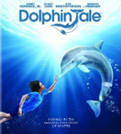
Dolphin Tale (2011) PG
Disability: Amputation, Prosthetic device
Summary: A story centered on the friendship between a boy and a dolphin whose tail was lost in a crab trap.
https://www.youtube.com/watch?v=kgyZjbzS18A

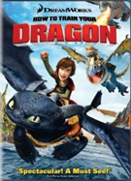
How to Train Your Dragon (2010) PG
Disability: Prosthetic device
Summary: Hiccup ventures out into battle and downs a mysterious Night Fury dragon with his invention, but can't bring himself to kill it. Instead, Hiccup injures the dragon, whom he dubs Toothless. They begin a friendship that would open up both their worlds and the boy creates a flight assisting “prosthetic” wing for Toothless. But even as the two each take flight in their own way, they find that they must fight the destructive ignorance plaguing their world.
https://www.youtube.com/watch?v=2AKsAxrhqgM

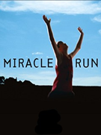
Miracle Run (2004) PG
Disability: Autism
Summary: Single mom Corrine discovers that her twins are autistic. She refuses to give up on their potential, even though it seems that the rest of the world has turned its back on them. Thanks to this incredible mother's support, her boys accomplish the unimaginable. Cast includes Aidan Quinn and Zack Efron as the male leads and Mary Louise Parker as the mother.
https://www.youtube.com/watch?v=tz58HKABjwg

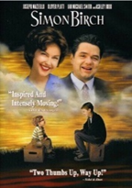
Simon Birch (1998) PG
Disability: Dwarfism
Summary: Simon Birch tells the story of Joe and Simon's heart-warming journey of friendship. Simon Birch was born with a condition that makes him much smaller than all the other kids in town. Now, due to his condition, Simon thinks God made him this way for a reason. Together, Joe and Simon go on a journey of trust and friendship to find the answers to many things. Their friendship is put to the test when some unfortunate events happen.
https://www.youtube.com/watch?v=AGU8cOHxSxo

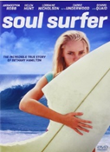
Soul Surfer (2011) PG
Disability: Limb loss, amputation
Summary: Based on a true story, teenage surfer Bethany Hamilton overcomes the odds and her own fears of returning to the water after losing her left arm in a shark attack
https://www.youtube.com/watch?v=_KlpD6dr7Qw

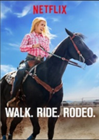
Walk. Ride. Rodeo (2019) PG Available to stream on Netflix
Disability: Paralysis, wheelchair user.
Summary: The incredible true story of nationally ranked barrel racer Amberley Snyder, who at 19 barely survives an automobile accident. Now paralyzed from the waist down, Amberley, with the support of her family, physical therapy and her own inspiring determination, fights to earn back her place in the sport she loves.
https://www.youtube.com/watch?v=BK0rbzLk0YI

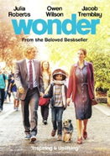
Wonder (2017) PG
Disability: Facial differences
Summary: Based on the New York Times bestseller, WONDER tells the incredibly inspiring and heartwarming story of August Pullman. Born with facial differences that, up until now, have prevented him from going to a mainstream school, Auggie becomes the most unlikely of heroes when he enters the local fifth grade. As his family, his new classmates, and the larger community all struggle to discover their compassion and acceptance, Auggie's extraordinary journey will unite them all and prove you can't blend in when you were born to stand out.
https://www.youtube.com/watch?v=ngiK1gQKgK8
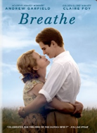
Breathe (2017) PG-13
Disability: Complications from polio
Summary: When Robin (Andrew Garfield) is struck down by polio at the age of twenty-eight, he is confined to a hospital bed and given only a few months to live. With the help of Diana's (Claire Foy's) twin brothers (Tom Hollander) and the groundbreaking ideas of inventor Teddy Hall (Hugh Bonneville), Robin and Diana dare to escape the hospital ward to seek out a full and passionate life together, raising their young son, traveling, and devoting their lives to helping other polio patients.
https://www.youtube.com/watch?v=JycCFypvgmI

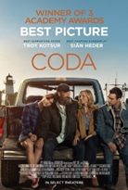
CODA (2021) PG-13. Available on Apple TV+
Disability: Deafness https://www.youtube.com/watch?v=0pmfrE1YL4I
Summary: Gloucester, Massachusetts. As a Child of Deaf Adults and the only hearing person in her family, high school senior Ruby Rossi always has a lot on her plate. Indeed, trying to juggle back-breaking work on her father's fishing boat, schoolwork, social life, and the family's expectations can be too much for a teenager. But do her parents know Ruby loves to sing? When Ruby signs up for the school choir, singing becomes a passion, and suddenly, the talented young girl finds herself at a crossroads: should Ruby spread her wings and follow her dreams, or should she keep fighting everyday battles as a member of the proud Rossi clan?


I Am Sam (2001) PG-13
Disability: Intellectual disability
Summary: Sam Dawson has the mental capacity of a 7 year old. He has a daughter whose homeless mother has abandoned them both. Sam's difficulties become problematic, and his daughter is taken away. Sam finds a lawyer who handles the case pro bono. In the process, Sam teaches her a great deal about love and whether it's really all needed.
https://www.youtube.com/watch?v=ir6_2EkhzAc

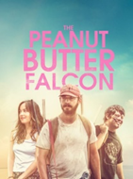
Peanut Butter Falcon (2019) PG-13
Disability: Down’s Syndrome
Summary: The Peanut Butter Falcon follows Zak, a Down's syndrome patient living in an assisted living home, as he runs away from his care home to make his dream of becoming a wrestler come true. Along the way he meets Tyler, a man on the run after committing a crime, and the two make an unbreakable bond as they spend days together learning about each other.
https://www.youtube.com/watch?v=UNl9RqjLCwc

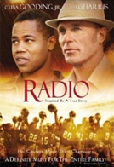

Radio (2003) PG-13
Disability: Intellectual Disability
Summary: The story of a high school coach and the developmentally challenged man whom he took under his wing. (Cuba Gooding Jr, Ed Harris.)
https://www.youtube.com/watch?v=bcfvpJvbYyU

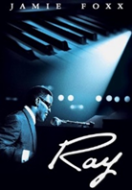

Ray (2004) PG-13
Disability: Blindness
Summary: The story of the life and career of the legendary rhythm and blues musician Ray Charles, from his humble beginnings in the South, where he went blind at age seven, to his meteoric rise to stardom during the 1950’s and 1960’s.

https://www.youtube.com/watch?v=jVHCQfcugdw

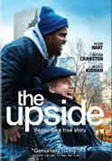

The Upside (2017) PG-13
Disability: Paralysis, wheelchair user
Summary: This is a remake of the French film The Intouchables (2011). Philip is a disabled billionaire, who feels that life is not worth living. To help him in his day-to-day routine, he hires Del, a parolee who is trying to reconnect with his estranged wife. What begins as a professional relationship develops into a friendship as Del shows his grouchy charge that life is worth living.
https://www.youtube.com/watch?v=EWw7rCHcduQ

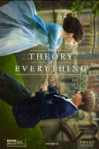
Theory Of Everything (2014) PG-13
Disability: Paralysis resulting from ALS, wheelchair user
Summary: The Theory of Everything is the story of the most brilliant and celebrated physicist of our time, Stephen Hawking, and Jane Wilde, the arts student he fell in love with while studying at Cambridge in the 1960s. Little was expected from Hawking, a bright but shiftless student of cosmology, after he was given just two years to live following the diagnosis of a fatal illness (ALS) at 21 years of age.
https://www.youtube.com/watch?v=Salz7uGp72c

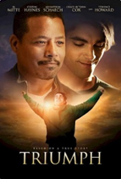

Triumph (2021) PG-13
Disability: Cerebral Palsy
Summary: A determined high-school senior strives to be a wrestler one last time despite having cerebral palsy and goes to extreme lengths, crushing obstacles and inspiring others along his journey to prove his abilities. Inspired by real events.

https://www.youtube.com/watch?v=WmKkp_ynnIc

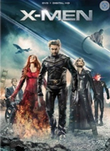

X-Men (2000) PG-13
Disability: Paralysis (spinal cord injury), wheelchair user
Summary: Professor X runs an academy for “mutants” — people with superhero powers. The X-Men team must defend themselves against anti-mutant legislation and the villainous mutants. Professor X (Patrick Stewart) uses a wheelchair.

https://www.youtube.com/watch?v=VNxwlx6etXI

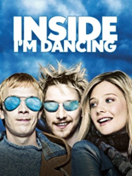
Inside I’m Dancing (Rory O’Shea Was Here) (2004) R
Disability: Cerebral palsy, wheelchair user
Summary: In Dublin, the disabled rebel Rory O'Shea moves to the Carrigmore Residential Home for the Disabled, affecting the lives of the residents. Rory is able to understand the unintelligible speech of Michael Connolly, who was left in the shelter by his prominent father many years ago due to his cerebral palsy, and they become close friends. Rory convinces Michael to move from Carrigmore to an apartment in Dublin, and they hire the gorgeous Siobhan to assist them. Living together with Rory, Michael faces a new world, finding friendship, love and freedom and learning to survive on his own. https://www.youtube.com/watch?v=m2X4M3WT0W4

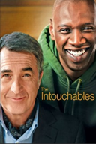
Intouchables (2011) R
Disability: Paralysis, wheelchair user
Summary: (In French with subtitles) In Paris, the aristocratic and intellectual Philippe is a quadriplegic millionaire who is interviewing candidates for the position of his caregiver, with his red-haired secretary Magalie. Out of the blue, Driss cuts the line of candidates and brings a document from the Social Security and asks Phillipe to sign it to prove that he is seeking a job position so he can receive his unemployment benefit. Philippe challenges Driss, offering him a trial period of one month to gain experience helping him. Then Driss can decide whether he would like to stay with him or not. Driss accepts the challenge and moves to the mansion, changing the boring life of Phillipe and his employees. https://www.youtube.com/watch?v=34WIbmXkewU

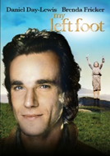
My Left Foot (1989) R
Disability: Cerebral palsy
Summary: My Left Foot' is the remarkable story of Christy Brown, born into a working-class Irish family with cerebral palsy. Growing up in a life full of poverty and extreme prejudice, Christy defied everyone's expectations. Using his left foot, the only part of his body he had proper control over, the young man learned to write and paint.
https://www.youtube.com/watch?v=xj7yME23Hes

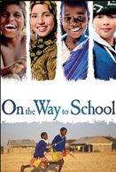

On The Way To School (2013) NR, suggested for ages 10 and up.
Disability: Paralysis, wheelchair user
Summary: Jackson, the Kenyan; Carlito, the Argentinian; Zahira, the Moroccan; Samuel, the Indian: four children who live light years away from each other and who have never met but who have a common point: they have to cover tremendously long distances to reach their school. On foot, on horseback or in a wheelchair, but all with an extraordinary determination.
https://www.youtube.com/watch?v=igqpoaZZUHQ

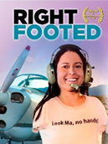
Right Footed (2013) NR suggested for ages 12 and up. Streams on Amazon. For more options and information go to: rightfootedmovie.com
Disability: Limb difference
Summary: Jessica Cox was born without arms, but managed to overcome many physical and emotional challenges to become fully independent. She learned to type with her toes, drive a car with her feet, and amazingly -- fly an airplane with her feet. Right Footed follows Jessica as she transforms from a motivational speaker to a mentor, and eventually into a leading advocate for people with disability.https://www.youtube.com/watch?v=NrTdU9AYZzM

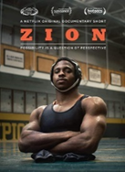
Zion (2018) NR. Available on Netflix
Disability: Limb difference, wheelchair user
Summary: A short, 12 minute, documentary on Zion Clark. Born without legs and raised in foster care, one teen finds confidence through competitive wrestling. Zion proves that possibility is a question of perspective. Winner of two Sports Emmy's and nominated for Short Film Grand Jury Prize at the Sundance Film Festival. https://www.youtube.com/watch?v=FWo0MN_tY1E

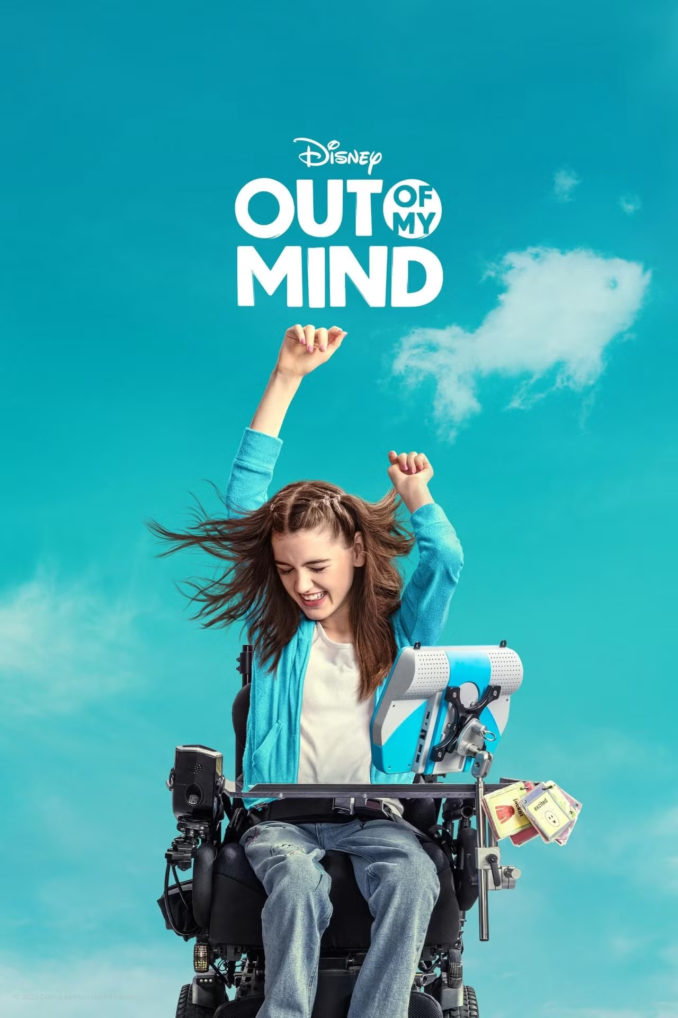
Out of My Mind (2024) PG: Available on Disney +
Disability: Cerebral Palsy
Summary : Melody Brooks is navigating sixth grade as a nonverbal wheelchair user who has cerebral palsy. With the help of some assistive technology and her devoted allies, Melody shows that what she has to say is more important than how she says it.
Out of My Mind | Official Trailer | Disney+

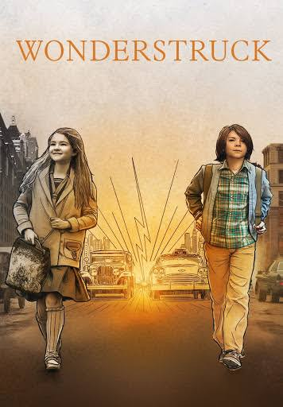
Wonderstruck (2017) PG: Available on Netflix
Disability: Deaf
Summary: The film interlaces two stories set fifty years apart, switching frequently between them. Each tells the story of a child's quest. In 1927, Rose runs away from her father's New Jersey home to find her mother/idol, the actress Lillian Mayhew. In 1977, recently orphaned Ben runs away from his Minnesota home in search of his father..
https://www.youtube.com/watch?v=o1vV0oorclg

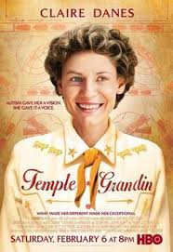

Temple Grandin (2010) TV- PG: Available on Netflix
Disability: Autism
Summary: Biopic of Temple Grandin, an autistic woman who overcame the limitations imposed on her by her condition to become a Ph.D. and expert in the field of animal husbandry. She loves animals! She developed an interest in cattle early in life while spending time at her Aunt and Uncle's ranch. She did not speak until age four and had difficulty right through high school, mostly in dealing with people. Her mother was very supportive as were some of her teachers. She is noted for creating her "hug box", widely recognized today as a way of relieving stress in autistic children, and her humane design for the treatment of cattle in processing plants, which have been the subject of several books and won an award from PETA. Today, she is a professor at Colorado State University and well-known speaker on autism and animal handling.

https://www.youtube.com/watch?v=cpkN0JdXRpM
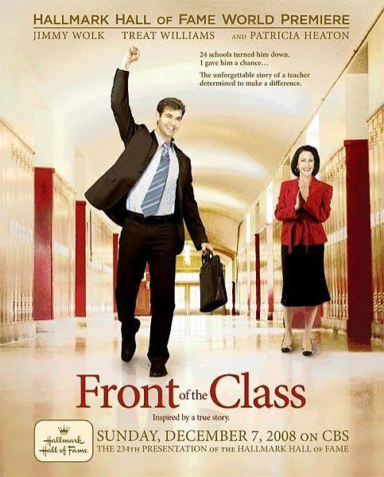

Front Of The Class (2008) PG
Disability: Tourette's Syndrome
Summary: After being challenged by Tourette's syndrome from a very young age, Brad Cohen defies all odds to become a gifted teacher. As Cohen grows up, he must face friends and classmates who don't realize that he sometimes cannot control his outbursts and a father who seems unwilling to accept his son's condition.
https://www.youtube.com/watch?v=hJDidwZ2_Wo

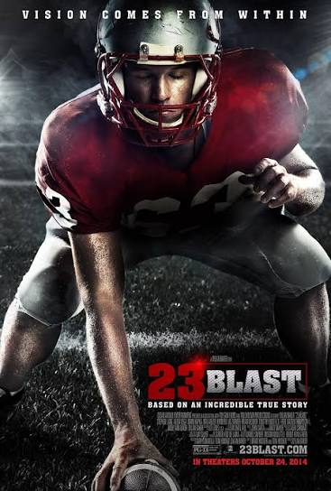
Blast (2014) PG13
Disability: Blind
Summary:In the prime of his youth, up-and-coming football star Travis Freeman lost his sight from a sinus infection caused by a rare disease. Overnight he became irreversibly blind and had to cope with new trials and changes. With the love and support of his family and closest friends, he learned to push himself to extraordinary heights. Relying on his other senses and his instincts, he did the unthinkable. Displaying unconditional determination he proved nothing could dampen the spirit of a champion.
https://www.youtube.com/watch?v=6jaZf7HvW8Y

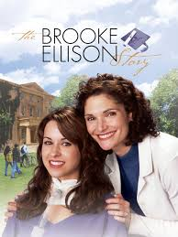

The Brooke Ellison Story (2004) PG
Disability: Quadriplegic
Summary: A young girl who has been a quadriplegic since childhood from a near-fatal neck injury fights against all odds to succeed in life from grade school to her acceptance to college with the assistance of her loyal, dedicated mother.
https://www.youtube.com/watch?v=aljsBTmK6c0

Short Films
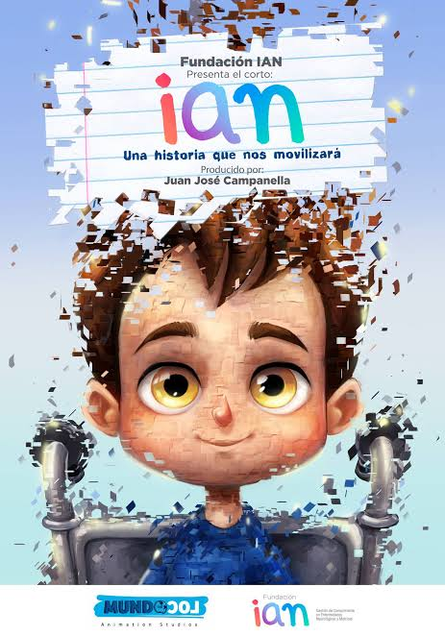
Ian (2018)
Disability: Cerebral Palsy
Summary: Ian was born with cerebral palsy. All he wants is to make friends, although it seems impossible to achieve when discrimination and bullying keep him away from his beloved playground. However, this young boy is determined and won't give up easily. The emotional animated short film shares a story about a boy with a disability called IAN. Ian's mother created IAN foundation to fight against the lack of information and knowledge that often lead people with disabilities to be bullied and isolated. The short Ian rises from the need and goal of this foundation to reach every home with an inclusion message. Sheila, Ian's Foundation founder and works to make society understand that when talking about inclusion there is no time to waste. This award-winning film was written and produced by Gastón Gorali and Oscar winner Juan José Campanella's Buenos Aires-based animation studio took home the top prize at LA Shorts International Film Festival and several major international awards.
https://www.youtube.com/watch?v=KsjVUJMWzks

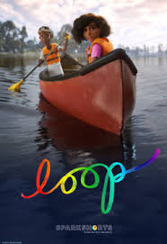
Loop (2020) PG:
Disability: Autism
Summary: In LOOP, two kids at canoe camp find themselves adrift on a lake, unable to move forward until they find a new way to connect and see the world through each other's eyes. This film breaks new ground by featuring Pixar's first non-verbal autistic character.
Disability: Autism
https://www.youtube.com/watch?v=PZdS-eAuT-k

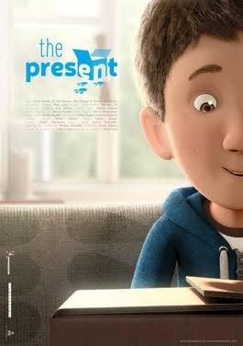
The Present (2014):
Disability: Limb Difference
Summary: The story of a boy who would rather spend his time indoors playing video games instead of discovering what's waiting outside the front door. One day his mother decides to get a little surprise for her son.
https://www.youtube.com/watch?v=3XA0bB79oGc

Documentaries

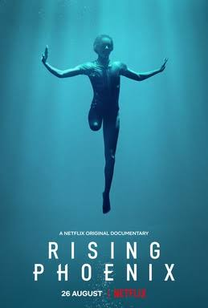
Rising Phoenix (2022):
Summary: The history and current standing of the Paralympic Games, which has grown to become the world's third largest sporting event.
https://www.youtube.com/watch?v=-W7Bek4jvos

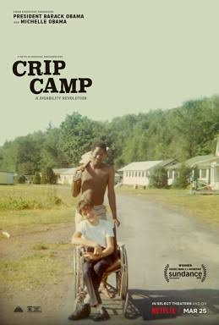

Crip Camp: A Disability Revolution (2020) R:
Summary: Down the road from Woodstock, a revolution blossomed at a ramshackle summer camp for teenagers with disabilities, transforming their lives and igniting a landmark movement.
https://www.youtube.com/watch?v=XRrIs22plz0

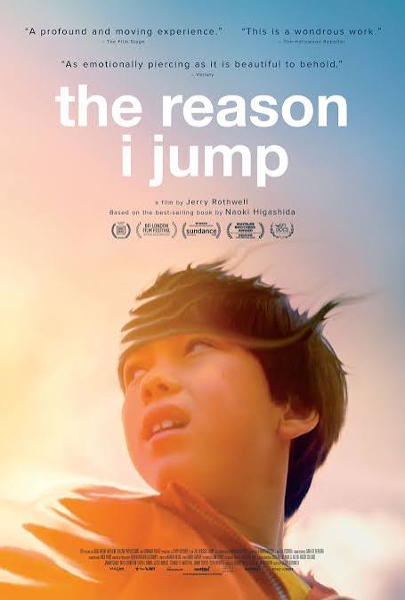
The Reason I Jump (2020):
Disability: Autism
Summary: Based on the book by Naoki Higashida, this immersive film explores the experiences of non-speaking autistic people around the world.
https://www.youtube.com/watch?v=J9ZxvR_cm94

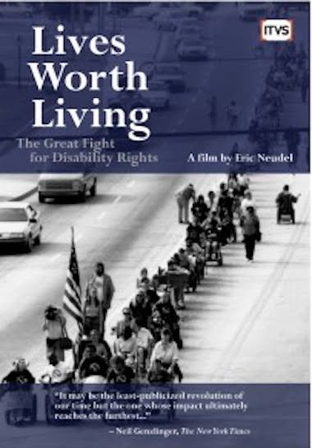

Lives Worth Living (2011)
Summary: Chronicles the American Disability rights movement
https://www.youtube.com/watch?v=RlXm9NJDacM

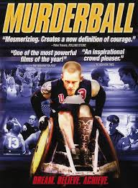
Murderball (2005)
Disability: Quadraplegic
Summary: Quad rugby as played by the US team, between 2002 games in Sweden and the 2004 Paralympics in Athens. Young men, most with spinal injuries, play this rough and tumble sport in special chairs, seated gladiators. We get to know several and their families. They talk frankly about their injuries, feelings in public, sex lives, competitiveness, and love of the game. There's also an angry former team member gone north to coach the Canadian team, tough on everyone, including his viola-playing son. We meet a recently injured man, in rehab, at times close to despair, finding possible joy in quad rugby. After Athens, the team meets young men injured in war: the future stars of Team USA.
https://www.youtube.com/watch?v=vbiFjp0jqto

