Fundraising
Ideas and Resources

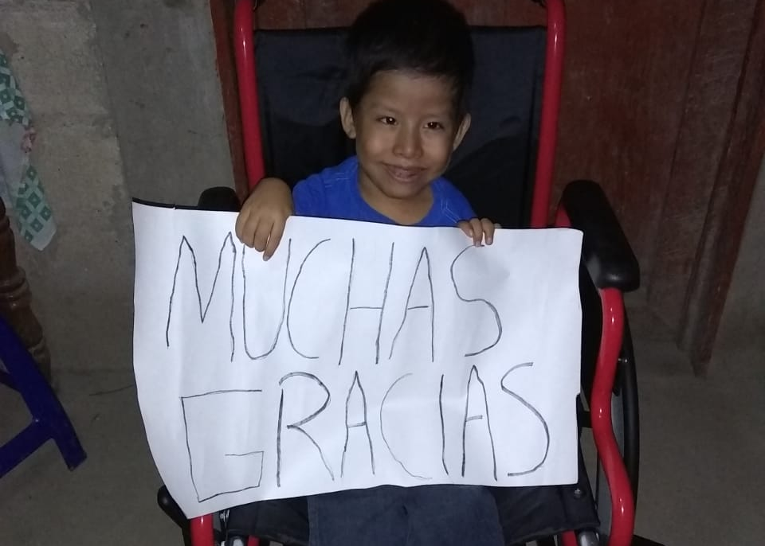

Introduction
These examples are options for your school to choose from. Each school should review the list and decide which options work best for their environment. Additional fundraising ideas can be obtained from www.fundraising-ideas.org/DIY or similar websites. It often helps to get support from the community by having publicity in local papers. If you need help with a contact at a local paper or have suggestions for future enhancements to this list please contact communityoutreach@wheelchairfoundation.org
List of Ideas and Resources
- Using Social Media to Promote The Wheelchair Foundation
  - If your club or school has a Facebook or Instagram page, you can set up a fundraiser for the Wheelchair Foundation! 100% of donations made via social media will go to our foundation and will be used for purchasing wheelchairs. For Facebook, simply have your club/school administrator of your FB page create a fundraiser by visiting Facebook.com/WheelchairFoundation and click on Fundraisers.
  - Be sure to identify the title of your fundraiser using your school’s name clearly so we can be sure to track your fundraising efforts. You will be able to share your fundraiser on your school media outlets as well on your clubs page or even your individual Facebook accounts.
  - If you have any questions please contact us at communityoutreach@wheelchairfoundation.org
- Use your school’s custom WCF donation webpage to create your own fundraising page. From there you can create a QR code for people to donate from. Send links to friends, family and businesses to your page. Partner with some friends and create a fundraising team!
- Using School Bus Banks and Collection Canisters to collect money daily or on “Wheelchair Wednesdays”
  - Encourage students to do extra chores at home. Some additional ideas are:
    - Lemonade or hot chocolate stands, babysitting, projects for neighbors, etc.
    - What extra chores would it take to donate the jar of coins that many parents have?
- Write persuasive letters to parents, friends, relatives and the community. For an example letter click here.
- Deliver the letters to local businesses during Wheelchair Awareness Week
- Ask local business owners and parents to place a collection canister at their business.
- Set goals to raise enough for XX wheelchairs.
  - Set up a Bulletin Board or ‘Thermometer’ to track progress and keep students informed.
- Have competitions between schools, classrooms, grades, clubs, etc.
- Use the “Flyer for Parents/Community” to communicate how to donate by check or online.
  - Many families have someone in their family who uses a wheelchair and want to make a tax-deductible contribution.
  - Ask local service clubs (e. g. Rotary) and/or local business owners to provide Matching Funds
- Arrange a “Wheel-A-Thon” and have students obtain sponsors that pay per lap
  - Other “Thons” could be Bowl, Dance, Jog, Walk, etc.
  - Ramps designed for wheelchair users are available at Danville and Dublin Bowl
- The Guidelines suggest many uses for the wheelchairs during Wheelchair Awareness Week.
  - Charge a fee to participate in these activities and collect donations from the audience
- For the High Schools, designate one of the major sporting events as a wheelchair fundraiser
  - Arrange a Wheelchair Basketball game between students and staff
  - Set up a Wheelchair Donation table and collect donations at other sporting events
- Have a family/student Movie Night during Ability Awareness Month
  - Click HERE to see a list of movies that feature characters with a disability

- Middle and High Schools have a “From the Heart” dance
  - Wheelchairs can be arranged for the evening even if it is not your week to have the wheelchairs
- Using the wheelchairs, collect donations at a local grocery store or Starbucks on the weekend of Wheelchair Awareness Week
  - Set up a table with signs, banners and use photos, etc.
  - The Wheelchair Foundation can provide supplies such as brochures and pins
- Raise money by serving others
  - Ask local service clubs (e. g. Rotary, Kiwanis, Lions, etc.) or local businesses to sponsor students for each hour they spend doing community service such as cleaning up a park, hiking trail or roadway, or volunteering at a homeless shelter, soup kitchen, etc.
- During the weekend that you have the wheelchairs have a “Wheelchair Car Wash”
  - “Wheelchairs washed for free – Cars cost $XX”
- Select a day that students, teachers and staff can wear their craziest hat to school.
  - Each person pays a fee and gets their hand stamped so that the teachers know they have paid.
  - Winners are selected according to originality, creativity and the hat that was most favored by students and teachers.
- Have a penny war between classes where pennies have a positive value and all other coins and bills have a negative value.
- Have a bake sale or recipe sale that includes some typical cuisine from Latin America

