

Bibliography

Books That Share The Disability Experience

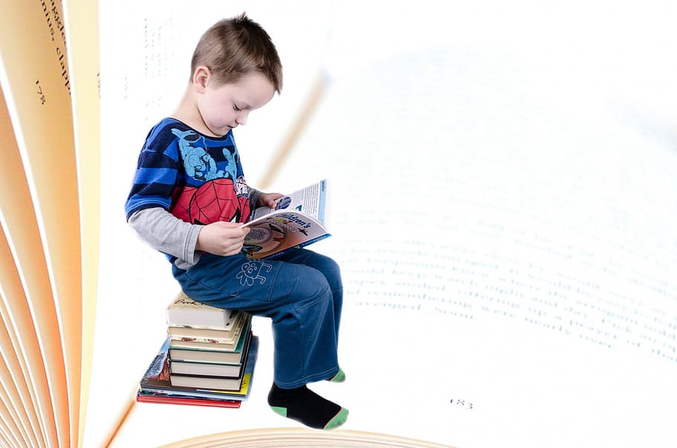
Introduction
These books are suggestions and may not be suitable for all readers. Please preview your selection before recommending it to students. The below synopsizes are from goodreads.com.
In addition, you may also choose to provide talking points to go along with the book, especially at the elementary level.

Elementary Level
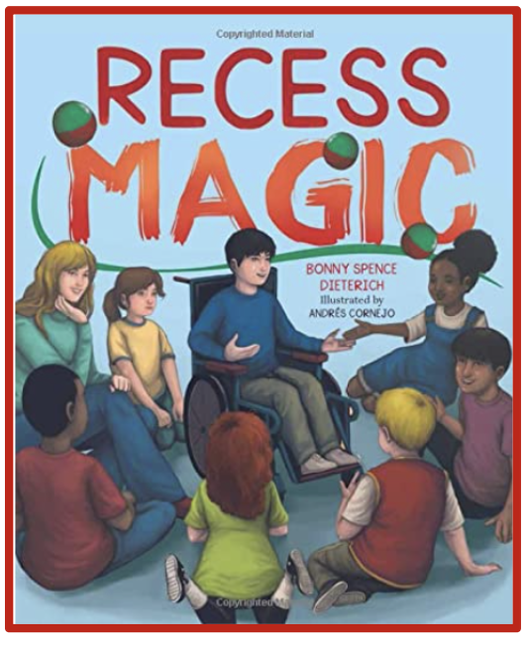
Recess Magic (2023)
Click HERE to see “Meet The Author” opportunities and more!
Age: 4-8

Summary: We are kind every day, and in every way. On Greyson’s first day at a new school, his excitement turns to embarrassment when a classmate is rude about his disability. At first, Greyson wants to hide. Then, with the help of family and friends, he discovers the courage to speak up. With his help, Greyson’s class learns the importance of understanding new perspectives. With kindness, empathy, and a little magic, a special friendship begins.
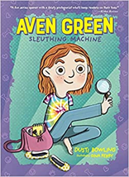
Aven Green Series (2021)
Age: Elementary Chapter Book
Summary: Three books in this award-winning series (Aven Green Sleuthing Machine, Aven Green Baking Machine and Aven Green Music Machine) are about the adventures and abilities of a 3rd grade girl born without arms.

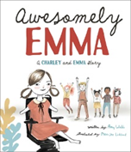
Awesomely Emma, 2020
Ages: Young Children (3-6 years)
Summary: Amy Webb's follow-up to When Charley Met Emma, Awesomely Emma will have all kids cheering as they learn to see the inner awesome in themselves and those around them.

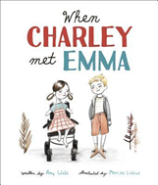
When Charley Met Emma, 2019
Ages: Young Children (3-6 years)
Summary: This delightful book will help kids think about disability, kindness, and how to behave when they meet someone who is different from them.

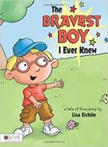
The Bravest Boy I ever Knew, 2010
Age: Young children (3-6 years)
Summary: What makes someone brave? Michael wants to introduce you to someone very important. This boy is just like you. He loves sports, puzzles, and being outside. He loves to race Michael, often beating him. This boy is a great best friend. Michael wants to be just like him because he's the bravest boy Michael knows. But why does Michael think he's so brave? Find out in The Bravest Boy I Ever Knew.
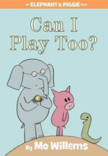
Can I Play Too? (2010)
Age: Young Children (3-6 years)
Summary: Gerald and Piggie meet a new snake friend who wants to join in a game of catch. But don't you need arms to catch?

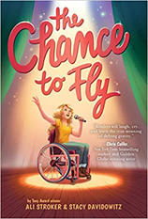
The Chance to Fly (2021)
Ages: 9-12 years
Summary: Thirteen-year-old Nat Beacon loves a lot of things: her dog Warbucks, her best friend Chloe, and competing on her wheelchair racing team, the Zoomers, to name a few. But there’s one thing she’s absolutely OBSESSED with: MUSICALS! From Hamilton to Les Mis, there’s not a cast album she hasn’t memorized and belted along to. She’s never actually been in a musical though, or even seen an actor who uses a wheelchair for mobility on stage. Would someone like Nat ever get cast?

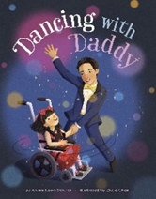
Dancing with Daddy (2021)
Age: young children (3-6 years)
Summary: Elsie can’t wait to go to her first father-daughter dance. She picked out the perfect dress and has been practicing swirling and swaying in her wheelchair. Elsie’s heart pirouettes as she prepares for her special night. With gestures, smiles, and words from a book filled with pictures, she shares her excitement with her family. But when a winter storm comes, she wonders if she’ll get the chance to spin and dance her way to a dream come true.

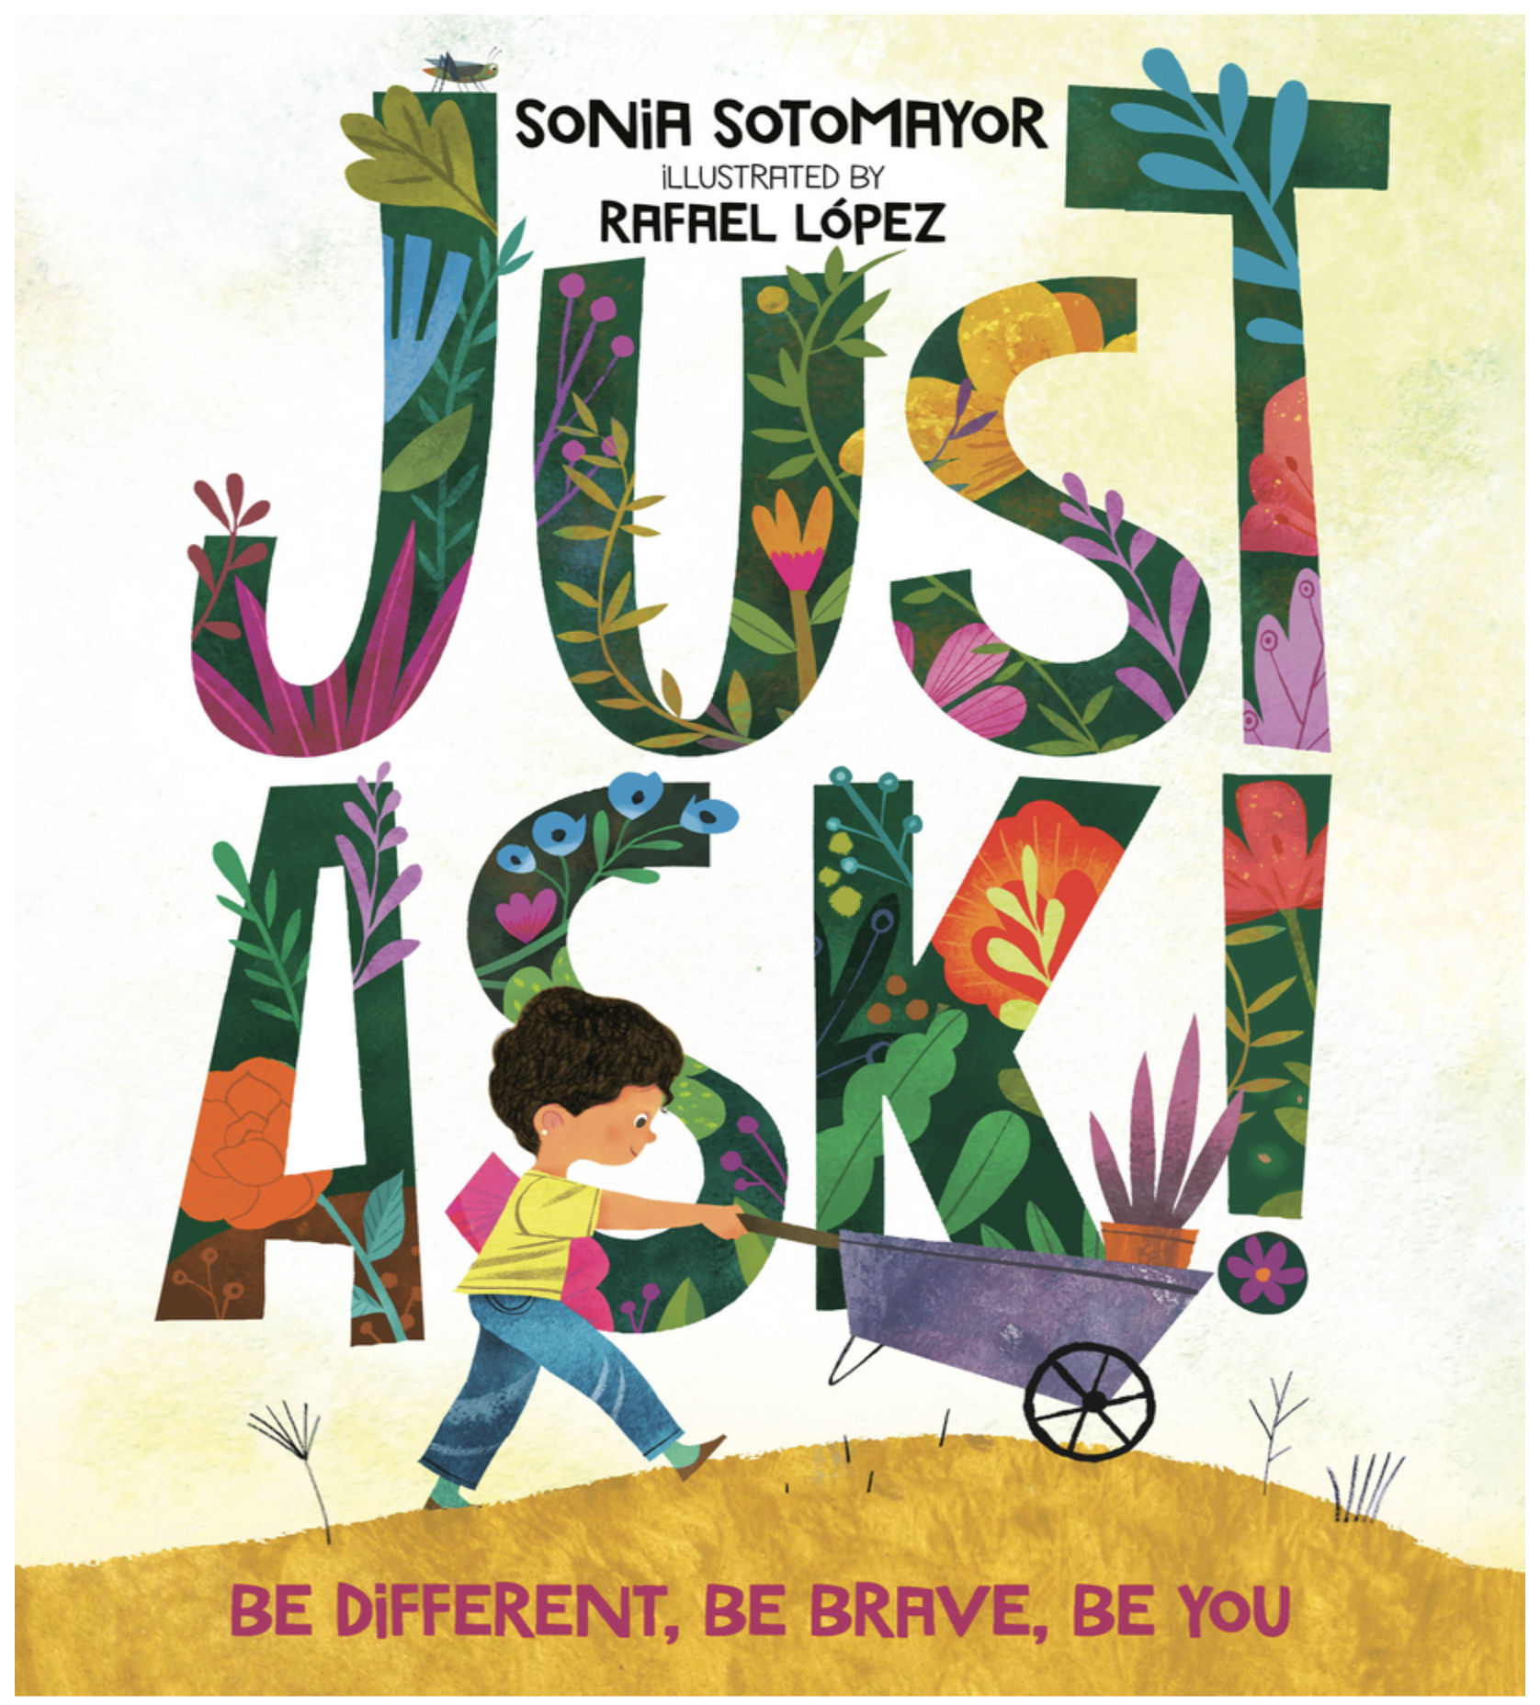
Just Ask! Be Brave, Be Different, Be You (2019)
Ages: Young Children (6-10 Years)

Summary: In Just Ask, United States Supreme Court Justice Sonia Sotomayor celebrates the different abilities kids (and people of all ages) have. Using her own experience as a child who was diagnosed with diabetes, Justice Sotomayor writes about children with all sorts of challenges—and looks at the special powers those kids have as well. As the kids work together to build a community garden, asking questions of each other along the way, this book encourages readers to do the same: When we come across someone who is different from us but we're not sure why, all we have to do is Just Ask.
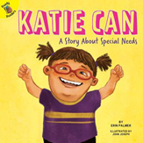
Katie Can (2018)
Age: 5-7
Summary: Katie has Down’s Syndrome, but that's not what makes her so special. Find out what makes Katie unique. This title focuses on sight words, decoding, and retelling.

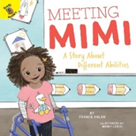
Meeting Mimi (2019)
Age: 4-8 years
Summary: Introduce your child to the magic of reading, friendship, and inclusion with Meeting Mimi: A Story About Different Abilities. The 24-page book features pictures and simple language to practice early reading comprehension skills.

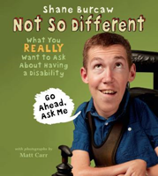
Not So Different (2017)
Age: 6-9 years
Summary: Not So Different offers a humorous, relatable, and refreshingly honest glimpse into Shane Burcaw’s life. Shane tackles many of the mundane and quirky questions that he’s often asked about living with a disability, and shows readers that he’s just as approachable, friendly, and funny as anyone else.

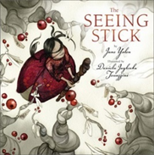
The Seeing Stick (3rd edition 2009)
Age: 3-6 years
Summary: The same story that captivated readers in 1977 is back in a stunning new edition! Hwei Min, the only daughter of the emperor of China, has been blind since birth. Her father offers a reward to anyone who can find a cure for the little girl. It seems that no one from magicians to physicians can help her. Then, one day a wise old man with a mysterious seeing stick visits the princess. Will he be able to teach Hwei Min that there is more than one way to see the world?
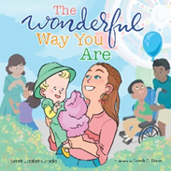
The Wonderful Way You Are (2020)
Age: 3-7 years
Summary: The Wonderful Way You Are creates a safe place for parents and caregivers to have a conversation about difference. Based on real special needs children, the book's vivid illustrations and rhyming text help each child see their own uniqueness reflected on the page.
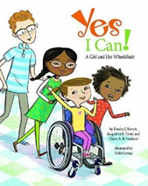
Yes I Can: A Girl And Her Wheelchair (2018)
Ages: 4-8 years
Summary: Carolyn is a happy, energetic, caring first-grader who just happens to be in a wheelchair. She’s excited to start her new year of school and make new friends. Yes I Can! follows Carolyn on a typical day at home, at school, and even on a field trip! She can do almost everything the other kids can, even if sometimes she has to do it a little differently.

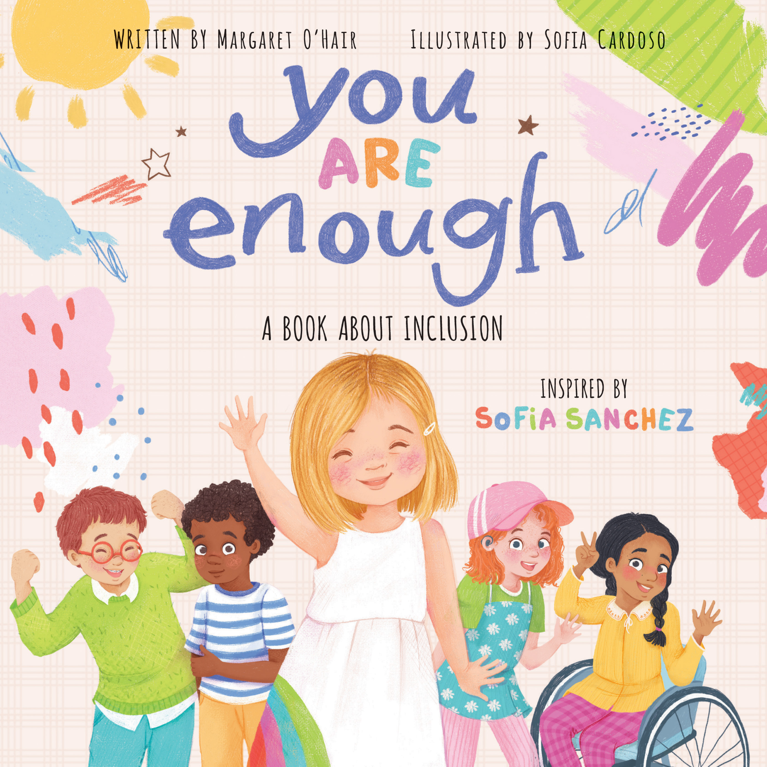
You Are Enough: A Book About Inclusion (2021)
Ages: 4-9
Summary: This inclusive and empowering picture book from Sofia Sanchez-an 11-year-old model and actress with Down syndrome-reminds readers how important it is to embrace your differences, be confident, and be proud of who you are. Each spread features beautiful, full-color illustrations of a full cast of kid characters with all kinds of backgrounds, experiences, and abilities.

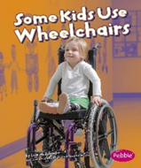
Understanding Differences (Some Kids Use Wheelchairs/Wear Leg Braces/Have Autism/Are Deaf/Are Blind) (Updated 2018)
Age: 5-7
Summary: There are 5 books in the set. Text and photographs discuss the various disabilities by topic. In Some Kids Use Wheelchairs the book covers why some children cannot walk, how wheelchairs help them, and the everyday activities of children who use wheelchairs.

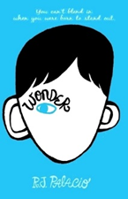
Wonder (2012)
Age: 9+ years
Summary: August Pullman was born with a facial difference that, up until now, has prevented him from going to a mainstream school. Starting 5th grade at Beecher Prep, he wants nothing more than to be treated as an ordinary kid—but his new classmates can’t get past Auggie’s extraordinary face.


Railway Jack: The True Story of an Amazing Baboon (2020)
Ages: 9-12 years
Summary: Jim was a South African railway inspector in the late 1800s who lost his legs in an accident while at work. Unable to perform all his tasks with his disability but desperate to keep his job, Jim discovered a brilliant solution, a baboon named Jack. Jim trained Jack to help him both at home and at the depot. But when the railway authorities and the public discovered a monkey on the job, Jack and Jim had to work together to convince everyone that they made a great team. This inspiring true story celebrates the history of service animals and a devoted friendship.
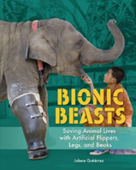
Bionic Beasts (2020)
Age: Children (9+ years)
Summary: Readers are introduced to the stories of five different animals from around the globe that are thriving thanks to prosthetic body parts. Each of these animals was at risk of dying due to their circumstances, but humans intervened, and using a variety of techniques and technologies, they were able to create prosthetics that enabled these animals to survive. Discover the amazing true stories of animals that have survived thanks to their prosthetic body parts.

Middle School And Older
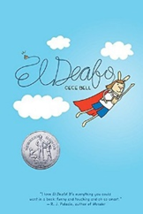
El Deafo (2014)
Age: Middle School
Summary: This funny perceptive graphic novel memoir about growing up hearing impaired is also an unforgettable book about growing up, and all the super and super embarrassing moments along the way.

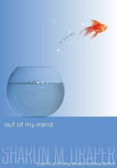
Out of My Mind (2010)
Age: Middle School

Summary: Melody is not like most people. She cannot walk or talk, but she has a photographic memory; she can remember every detail of everything she has ever experienced. She is smarter than most of the adults who try to diagnose her and smarter than her classmates in her integrated classroom - the very same classmates who dismiss her as mentally challenged because she cannot tell them otherwise. But Melody refuses to be defined by cerebral palsy. And she's determined to let everyone know it - somehow.
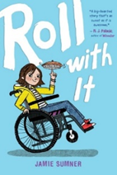
Roll With It (2020)
Age: Middle School
Summary: In the tradition of Wonder and Out of My Mind, this big-hearted middle grade debut tells the story of an irrepressible girl with cerebral palsy whose life takes an unexpected turn when she moves to a new town.

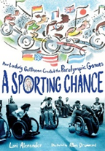
A Sporting Chance (2020)
Age: Middle School
Summary: Telling the inspiring human story behind the creation of the Paralympics, this chapter book biography artfully combines archival photos, full-color illustrations, and a riveting narrative to honor the life of Ludwig Guttmann, whose work profoundly changed so many lives.
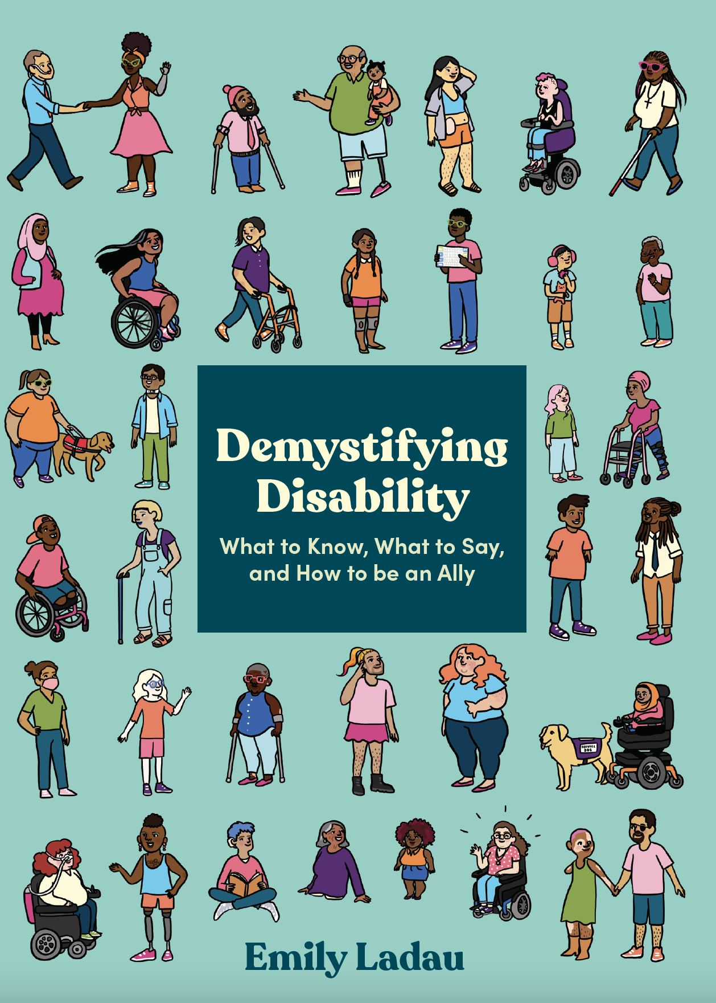
Demystifying Disability: What to Know, What to Say and How to Be an Ally (2021)
Ages: Adult
Summary: An approachable guide to being a thoughtful, informed ally to disabled people, with actionable steps for what to say and do (and what not to do) and how you can help make the world a more accessible, inclusive place.
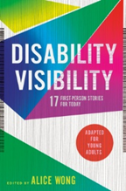
Disability Visibility (adapted for Young Adults in 2021)
Age: Young Adults (12+ years)
Summary: The seventeen eye-opening essays in Disability Visibility, all written by disabled people, offer keen insight into the complex and rich disability experience, examining life's ableism and inequality, its challenges and losses, and celebrating its wisdom, passion, and joy.

