Abilities Awareness
Timeline and Checklist

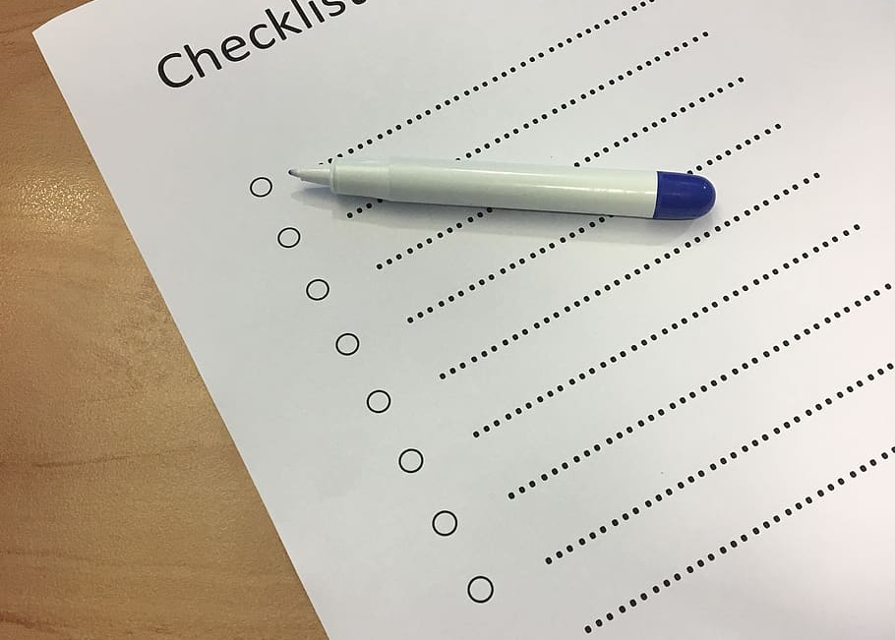

Introduction

The following timeline is suggested only. Upon first implementation based on the Ability Awareness Program format and supportive activities chosen, a school site may need the entire four months for planning, but subsequent years may require less time. A message that can’t be too strongly delivered is that Ability Awareness is YOUR PROGRAM – make it as comprehensive as your school site is able. Is there a particular lesson, supportive activity or opportunity to excel that speaks to your school community’s needs? Then go for it: Be enlightened, be educated, be awesome!
AS SOON AS POSSIBLE
- Meet with school staff leadership to confirm dates for your program.
- Email the Wheelchair Foundation at: communityoutreach@wheelchairfoundation.org to reserve your dates. It is important to reserve your dates as early as possible as we only have two sets of wheelchairs.
- Arrange a Wheelchair Foundation representative to speak at a staff meeting to give a brief overview of the program and the resources available. This will be invaluable to the success of your program.
3-4 MONTHS AHEAD
- Review the Wheelchair Foundation School Program Guide and the Ability Awareness Program Guide provided by San Ramon Valley Unified School District Exceptional Education Committee. To contact SRVUSD EEC directly contact Amy Capurro.
- Meet with the school principal to decide on the general format of the program and what types of supportive activities will work for your school. Request:
      - To attend and speak to the teachers at their regular staff meeting (1st delivery of Ability Awareness Program only)
      - The names of at least 2 teachers who would be interested in selecting the Supportive Activities
      - An introduction to the PTA president or contact in the PTA and Special Needs Parent Committee.
      - Introductions to student leadership and appropriate student clubs.
- Get support!
  - Reach out to PTA, Special Needs Parents Committee, Staff, student leadership, student council, and student clubs for volunteers, help and support.
  - Consider parent volunteers
  - Coordinate and delegate responsibilities. The broader participation the more impactful the program!

Once a format and dates are established:
- Develop your fundraising strategy. Click HERE for some ideas.
- Send the Wheelchair Foundation your school’s logo and a background picture to set up your custom online donation landing page. The Wheelchair Foundation does all the work to create your school’s page . Here is an example.
- Help your leadership students brainstorm and begin to coordinate activities.
- For high school and middle school, wheelchair basketball games are a lot of fun!
- How will the wheelchairs be used? See “ Week Of Wheelchairs: Ideas To Make An Impact”
- What lunchtime activities do they want to organize?
- Decide which day will be your kick-off day and when to have a WCF assembly speaker come. Presentations can be made to the whole school at one time, or can be given throughout the day during a class period, like english.
- Promotion! How will your school promote the events? Some ideas to think about are: Staff and/or students to cheer on classmates during student pick-up (from a wheelchair, of course!), daily announcements, email blasts, posters, social media.

  - Meet with the PTA to present the Ability Awareness Program and request funding and volunteers. See Appendix 2 in the San Ramon Valley AA Guide for estimated costs and budget.

3 MONTHS AHEAD
- Attend a teachers meeting with Wheelchair Foundation representative:
  - Have WCF representative give a brief presentation about the program.
  - Ask for assistance in choosing Supportive Activities if not already chosen.

2-3 MONTHS AHEAD
Speak with:
- Music or Choral teachers about supportive activities in their areas. For example the sign language song in Appendix 9, “The Don’t Laugh At Me Song,” or other similar-themed songs.
- Librarian to plan activities and check out books. Click HERE for a list of recent books about the disability experience from the WCF. For an older, but extensive list see: Appendix 10 in the SRV AA Program Guide
- P.E teacher to plan adaptive P.E. activities, for either class P.E. time or recess times. For some ideas click HERE.
- Art teacher or docent to highlight great artists that were known to have learning challenges or differences. See Appendix 8 in the SRV AA Program Guide.
- Principal to firm up details for outside-the-class Supportive Activities, which may include assemblies, parent education nights, family movie nights, and lunchtime activities. For a list of movies that include the disability experience, click HERE.
- Room parents can advertise Ability Awareness Program to classroom parents and look for volunteers (if necessary)

2 MONTHS AHEAD
- Identify and approach individuals for additional assembly activities: speakers etc. See Appendix 6 in the SRV AA Program Guide for assistance.
- Draft lead up articles and advertising for the school communications. If this article is written by the principal this gives the Ability Awareness Program more importance. See Appendix 4 in the SRV AA Program Guide for letter examples.

1-2 MONTHS AHEAD
Continue to plan schedule of activities:
- Reach out to initiative leads (staff, students, PTA, etc.) to make sure planning is on track.
- Design and complete poster for the front of the school. (Student leadership? PTA?) Additionally, WCF will supply a vinyl banner and posters.

2 WEEKS AHEAD
- Hang posters on the school grounds.
- Use these flyers to get the word out: (Faculty, Parents/Community and Athletic teams. All three flyers can be downloaded and edited.
- Post information on your school website, including this 90-second WCF video.
- Publish first Principal letter in school communications. Click HERE for an example.
- Collect supplies and coordinate volunteers.

1 WEEK AHEAD
- Confirm all arrangements with all participants: i.e., volunteers, speakers, outside agencies etc.
- WCF will reach out to confirm the assembly presentation schedule and delivery of the 10 wheelchairs. All wheelchair deliveries and pick-ups are done in the morning Friday-Friday by the Wheelchair Foundation.
- WCF coordinator to drop off kick-off supplies which include: banners, posters, collection canisters/school buses, cash collection bag.
- Put together school bus collection boxes (elementary).
- Use the flyers, videos and principal letters, and link to WCF donation page to put on your website and distribute through school’s newsletters and/or Peachjar.
- Remind teachers of the school assembly schedule.
- Publish second Principal letter in school communications. (See Appendix 4 in the SRV AA Program Guide for letter examples.)

KICK-OFF DAY
- Set up MPR for assembly with a projector, screen and microphone.
- Set out collection canisters/school buses in each classroom and office.
- Hang posters, banners and fliers
- Run your program and Have Fun!

POST PROGRAM
- Contact WCF representative to coordinate pick up of your collections and supplies. More than one pick up can be coordinated.
- Put money collections in the plastic bag provided with your school’s name on it.
- Have wheelchairs delivered to the front of the school on your pickup day (Friday morning)
- Schedule a date for your free field trip to the Blackhawk Museum. For more information go to: https://www.wheelchairfoundation.org/fth/field-trips/
- Remind teachers, staff, and students over 15 to consider traveling with us this summer for our distribution trip! We have scholarships available to both teachers and students! For more information go to: www.wheelchairfoundaiton.org/fth/distribution-trips/

