**YOU CAN MAKE A DIFFERENCE**

Give the gift of Mobility, Freedom, Dignity and Hope.

**HELP US REACH OUR GOAL**

***Did you know?***

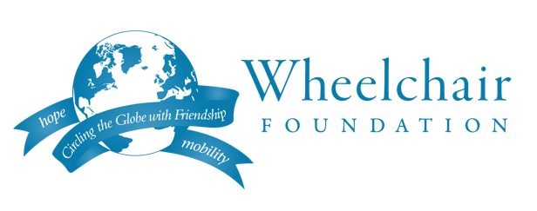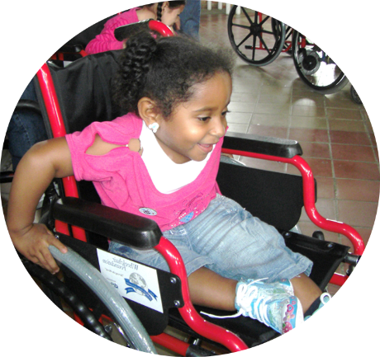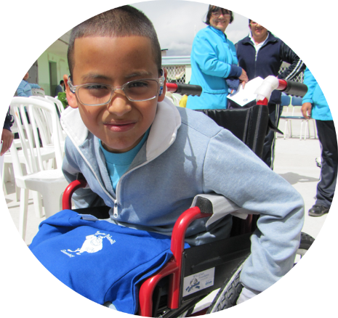

[Replace this text with a QR Code from Classy Donation page]

*The Wheelchair Foundation is a 501(c)3 Charitable Foundation – All donations are tax deductible.

* You can donate online by using the QR code to the right.
* Each Athletic Team is raising money for at least one wheelchair
* Checks should be made payable to the **Wheelchair Foundation**
* *100 million people need a wheelchair worldwide, but can’t afford one.*
* *30 million are children and 90% of them are unable to go to school.*
* A new wheelchair donated through the Wheelchair Foundation only costs $200*

[School name followed by ‘Athletics’]

Contact Coach for more information.

*Changing lives*

*TOGETHER*

&