YOU CAN MAKE A DIFFERENCE
Give the gift of mobility. Provide freedom and dignity.
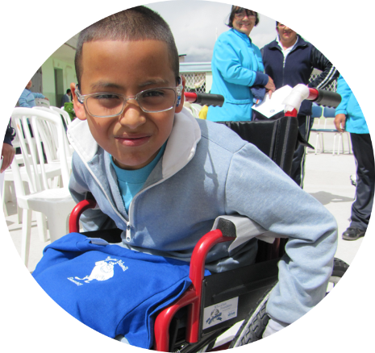
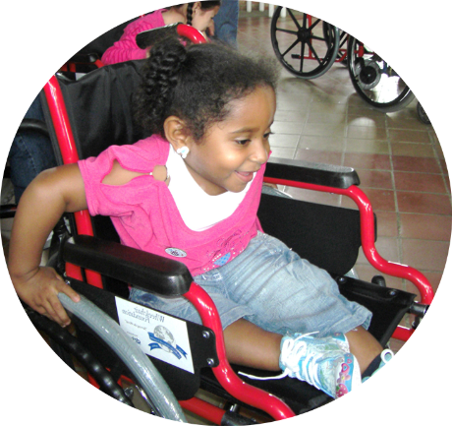
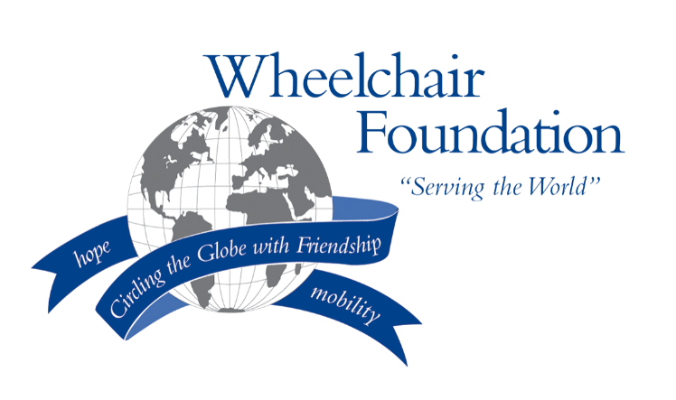
Create hope for the future.
[Insert school
name or logo]
HELP US REACH OUR GOAL
(At bottom of form, select “From The Heart – Schools Project” and indicate school name)
501(c)3 Charitable Foundation – All donations are tax deductible.
- Provide students with opportunities to earn money to donate
- Send in checks payable to the Wheelchair Foundation
- Donate Online at wheelchairfoundation.org

100 million people need a wheelchair worldwide, but can’t afford one.
30 million are children and 90% of them are unable to go to school.

A new wheelchair donated through the Wheelchair Foundation only costs $150

Did you know?
changing lives
TOGETHER
&
Contact _____________________ or _____________________ for more information.

